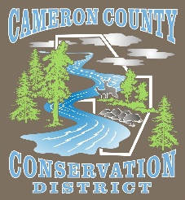
Cameron County Conservation District
Board of Directors Meeting

Date: May 11, 2026
TIME: 4:30 P.M.
PLACE: Conservation District Office
CALL IN NUMBER 814-486-9313 Password: 272727

AGENDA
Call to Order
Introduction of Guests & Comments
Minutes of April Meeting
Treasurer’s Report
Bills to be Paid
District Managers Report
Conservation Resource Technician Report
Watershed Technician Report
Administrative Assistant/Educator Report
Agency Reports

OLD BUSINESS

- None
NEW BUSINESS

- DGLVR Project Approval
  - Lumber Twp LVR (Sterling Run Road)
  - Lumber Twp DGR (May Hollow Road
  - Gibson Twp DGR (Jerry Run Road)

- 2026 Scholarship

- 26/27 Watershed Specialist Grant Renewal

GOOD OF THE ORDER

ADJOURN

