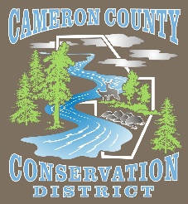
Cameron County Conservation District
Board of Directors Meeting

Date: October 14, 2025
TIME: 4:30 P.M.
PLACE: Conservation District Office
CALL IN NUMBER 814-486-9313 Password: 272727

AGENDA
Call to Order
Introduction of Guests & Comments
Minutes of September Meeting
Treasurer’s Report
Bills to be Paid
District Managers Report
Conservation Resource Technician Report
Watershed Technician Report
Administrative Assistant/Educator Report
Agency Reports

OLD BUSINESS

- ACAP
  - Amendment Lyon Project
  - Amendment Nelson Project

NEW BUSINESS

- Boots – Conservation Resource Tech and Watershed Specialist

- MAYH13 Intake Retrofit

- 2026 Cost of Living Increase

GOOD OF THE ORDER

ADJOURN

