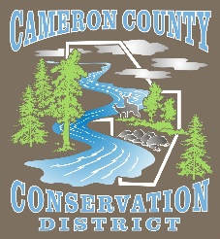
Cameron County Conservation District
Board of Directors Meeting

Date: Monday August 14, 2023
TIME: 4:30 P.M.
PLACE: Conservation District Office
CALL IN NUMBER 814-486-9313 Password: 272727

AGENDA
Call to Order
Introduction of Guests & Comments
Minutes of July Meeting
Treasurer’s Report
Bills to be Paid
District Managers Report
Conservation Resource Technician Report
Watershed Technician Report
Administrative Assistant/Educator Report
Agency Reports

OLD BUSINESS

- State Budget Update

NEW BUSINESS

- DGR
  - Project Approval
  - QAB Policy Update

- Hunts Run Liming Project Wrap Up

- 2022 Audit Acceptance

GOOD OF THE ORDER

ADJOURN

