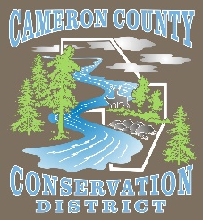**Cameron County Conservation District**

**Board of Directors Meeting**

**Date: Monday, January 10, 2021**

**TIME: 4:30 P.M.**

**PLACE: Cameron County Conservation District**

**CALL IN NUMBER 814-486-9313 Password: 272727**

**AGENDA**

Call to Order

Oath of New Directors

Introduction of Guests & Comments

Election of Officers

Minutes of December Meeting

Treasurer’s Report

Bills to be Paid

District Managers Report

Conservation Resource Technician Report

Watershed Technician Report

Administrative Assistant/Educator Report

QAB/ Dirt & Gravel

Agency Reports

**OLD BUSINESS**

* First Aid Kit

**NEW BUSINESS**

* Keystone Coldwater Conference
  + Watershed Specialist and District Manager to attend.
* Staff Apparel
* Ag Producers Meeting
* 2022 Budget

**GOOD OF THE ORDER**

**ADJOURN**