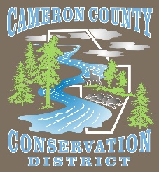**Cameron County Conservation District**

**Board of Directors Meeting**

**Date: Monday February 13, 2023**

**TIME: 4:30 P.M.**

**PLACE: Cameron County Conservation District**

**CALL IN NUMBER 814-486-9313 Password: 272727**

**AGENDA**

Call to Order

Introduction of Guests & Comments

Election of Officers

Minutes of January Meeting

Treasurer’s Report

Bills to be Paid

District Managers Report

Conservation Resource Technician Report

Watershed Technician Report

Administrative Assistant/Educator Report

QAB/ Dirt & Gravel

Agency Reports

* NRCS Civil Rights Responsibilities for Partners Checklist

**OLD BUSINESS**

* ACAP Update

**NEW BUSINESS**

* 2023 Grazing Conference Scholarships
* CCOYA Donation Request (Kevin Lovegreen Presentation)
* Headwaters Sinnemahoning Stakeholders Update

**GOOD OF THE ORDER**

**ADJOURN**