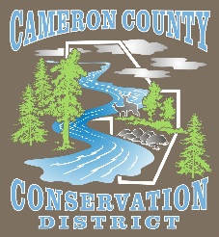
Cameron County Conservation District
Board of Directors Meeting

Date: September 8, 2025
TIME: 4:30 P.M.
PLACE: Conservation District Office
CALL IN NUMBER 814-486-9313 Password: 272727

AGENDA
Call to Order
Introduction of Guests & Comments
Minutes of August Meeting
Treasurer’s Report
Bills to be Paid
District Managers Report
Conservation Resource Technician Report
Watershed Technician Report
Administrative Assistant/Educator Report
Agency Reports

OLD BUSINESS

- Clearfield EWP Sponsorship

- Sterling Run Conservation Celebration Update

NEW BUSINESS

- CDFAP Allocation

GOOD OF THE ORDER

ADJOURN

